- Why do we need exceptions?
  - Unexpected situations
    - I/O errors
    - Network errors
    - Out of memory
    - Security Issues – Access denied
  - Programming Errors
    - Arithmetic errors
      - Divide by Zero
      - Overflow
    - Index out of range
  - If the error occurs deep inside the code
    - it is difficult to percolate the error code up to the right level
    - Most programmers don’t program for error conditions
- Sample code – Exception1
  - Divide by Zero (integer or decimal)
  - Introduce try…catch…finally
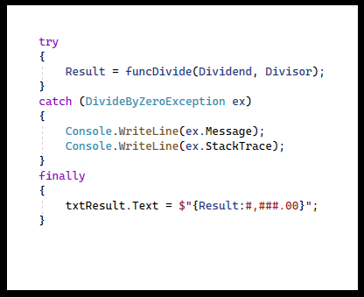
    - try section – guarded code
    - catch section(s) – type of exception to catch
      - Common properties of Exception
        - Message
        - StackTrace
      - Hierarchy of common exceptions
    - finally section … always executed

  - When an exception is thrown, the call stack is collapsed one level at a time looking for a catch block which matches the exception being thrown
  - Unhandled Exceptions
    - Debug Mode
    - Release Mode
  - Common Exception types
- Exception Properties
  - Message
  - Stack Trace
  - Inner Exception
- Catching and Throwing Exceptions
  - throw your own
  - throw – rethrow exception
  - throw ex – not recommended
- Custom Exceptions – ‘Custom’ project
  - Exception MyException thrown
  - Note Inner Exception

